2D Level Design Concept

Zach Norton

Level Design 1304 – 1051

Table of Contents
Table of Contents 2
Back Story 2
Level Map 3
Walk-Through 4
GUI Design 4
Interactive Elements 5

Back Story

A thief and a princess met each other in the middle of a bazaar and fell in love with each other at first sight. The thief not able to marry her because she is a princess, decides to disguise himself as a prince to be able to marry her. When arriving at the palace, you find out she has been taken by an evil and powerful sorcerer to force the princess to become his wife. You are told that the sorcerer took the princess to a secret cave of treasure and mystical power. So now the thief must make it through the guarded streets and bazaars out of the city to the secret cave. After escaping the City, the Thief trails the Princess and Sorcerer to the cave hidden in the middle of the dessert. After entering the cave, the Thief must make his way through enemies and collect gems to open the throne room doors to retrieve the Princess. The Princess is now save, but the Thief must return to the Palace in the city. He needs to fight his way into the throne room to the Sorcerer and defeat him.

Level Map

Retrieve three Keys to open the Throne Doors to retrieve find the Sorcerer
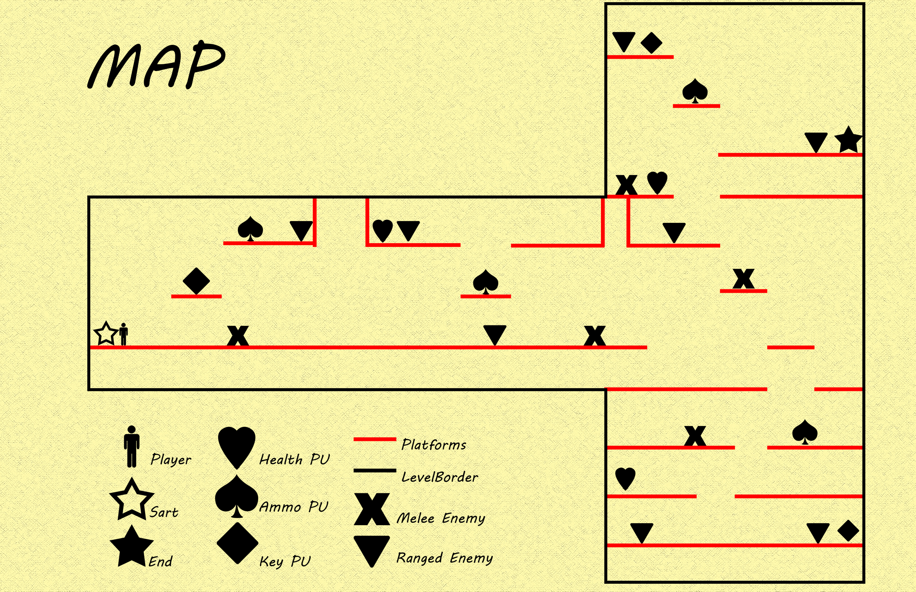

Walk-Through
Starting inside the Palace, explore through the palace and below in the Dungeon. On your way you will encounter melee Snakes and ranged enchanted Torches. Ranged Torches shoot Fire and melee Snakes attack close depleting your health. The player loses the level if the enemies deplete his health to zero. You can attack back with throwing daggers to take away their health until they are eliminated. If you need health or more throwing daggers, picking up hearts (replenish health) and dagger belts (gives more dagger ammo) are around the entire level to pick up when walked over. Around certain areas of the level, There are keys placed. Pick up the keys until you have three, and get to the top floor of the palace to open the throne room door. When the keys are presented, the door will open allowing you to win the level.
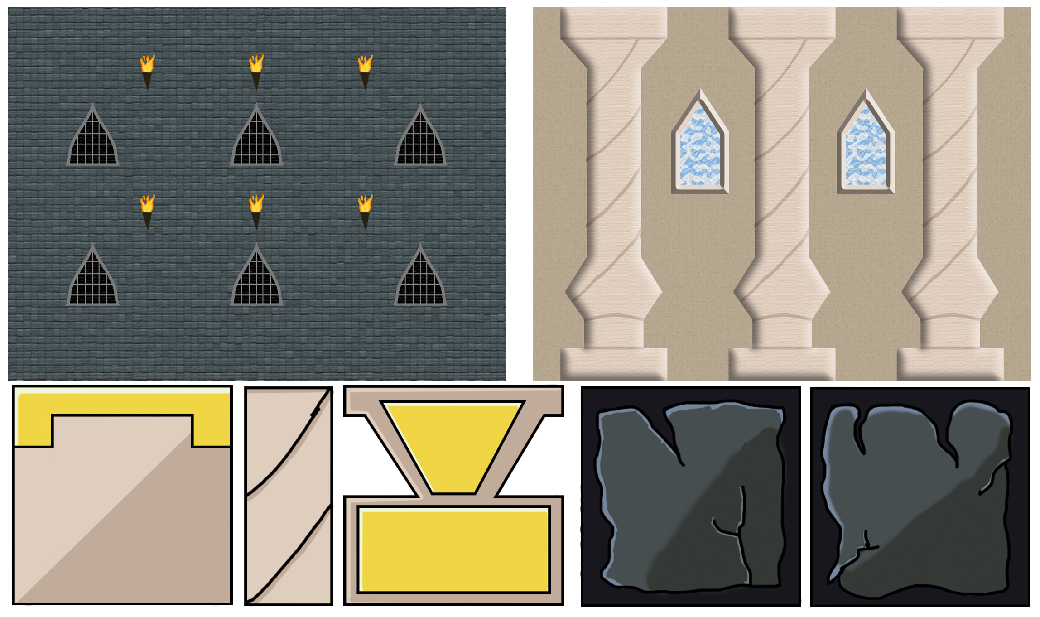

GUI Design
The HUD consists of a Health Bar that depletes when the player is hit, and replenished when health is picked up. A Key Inventory Bar that is filled when gems are picked up until there are three keys. Also a Throwing Dagger counter indicating how many the player has to throw at enemies and can be increased with dagger belt pickups. The art style is to reflect the Arabian look with gold and brass accents to fit royalty.
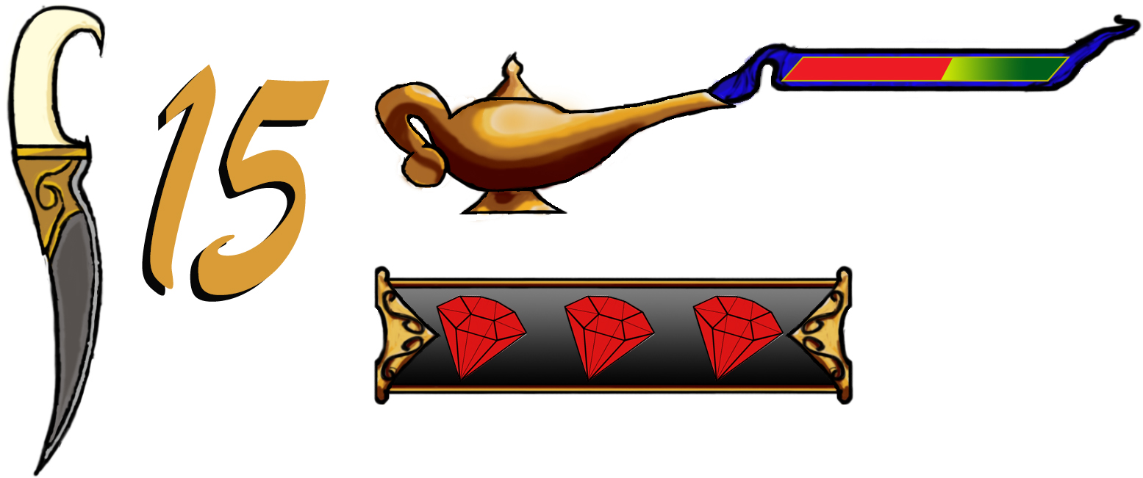

Interactive Elements
Enemy
There are large Melee Snakes with tan and black scales with orange accents. Also Ranged Torches made of Metal with a large flame on top. The Ranged Torches launch Fire as the projectile to deplete the player’s health. While the Melee Snakes attack the player with their fangs at close range to take away health at a certain rate.
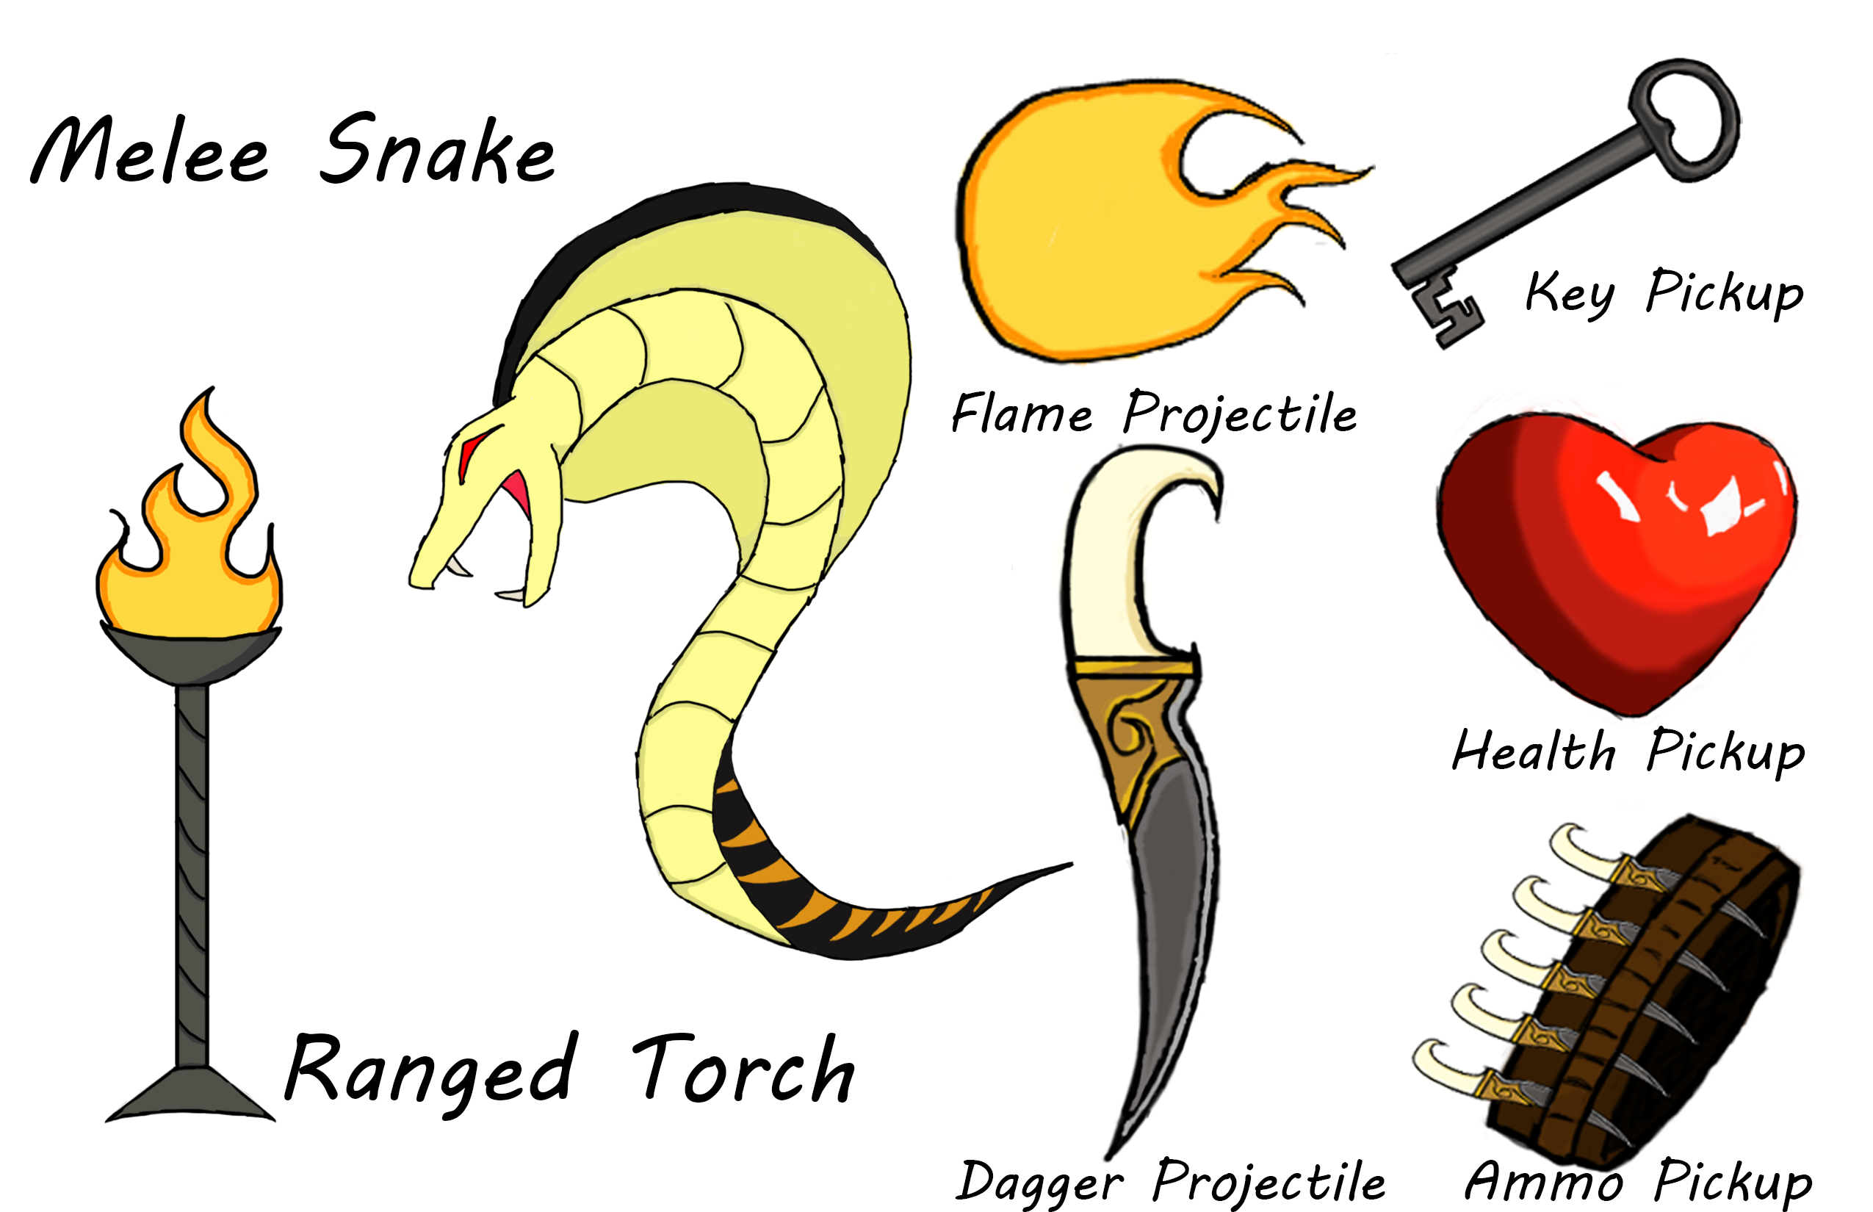
Pickups
When the player needs health, there is a red heart shaped pickup that will fully heath to 100% when collided with. There are leather belts holding daggers to pick up when collided with which will increase the amount of daggers the player currently has. Lastly there are Metal Keys for the player to pick up which are used to open the throne room door when the player as enough keys.

